30th Sunday in Ordinary Time
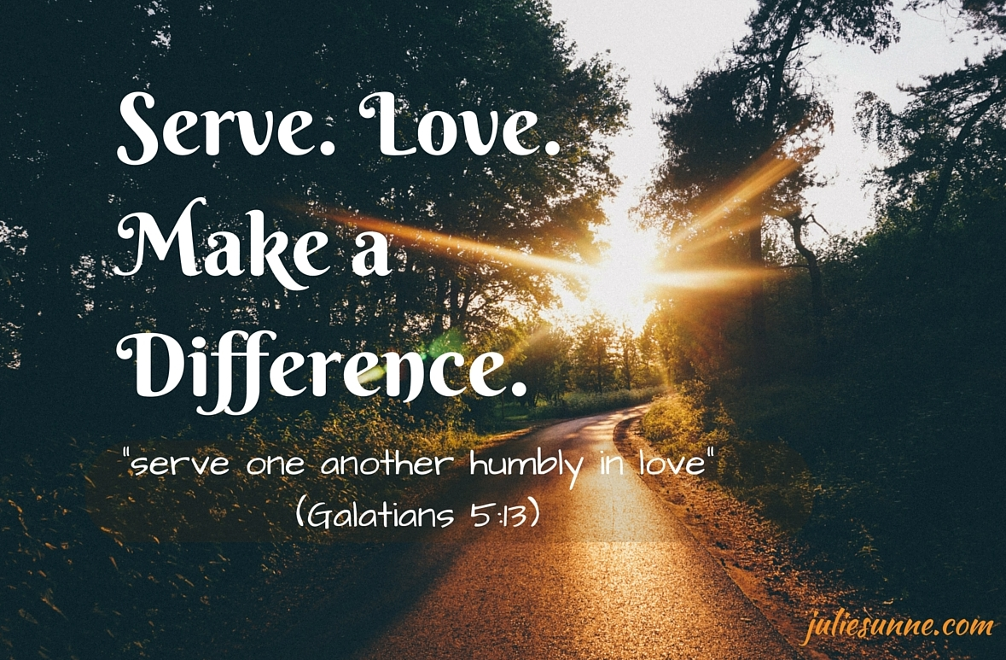

1st Reading: Exodus 22:20-26
The Israelites must show fairness in practical matters
The Lord said to Moses, “Tell the children of Israel this:
You shall not wrong or oppress a resident alien, for you were aliens in the land of Egypt. You shall not abuse any widow or orphan.
If you do abuse them, when they cry out to me, I will surely heed their cry; my wrath will burn, and I will kill you with the sword, and your wives shall become widows and your children orphans.
If you lend money to my people, to the poor among you, you shall not deal with them as a creditor; you shall not exact interest from them.
If you take your neighbour’s cloak in pawn, you shall restore it before the sun goes down; for it may be your neighbour’s only clothing to use as cover; in what else shall that person sleep? And if your neighbour cries out to me, I will listen, for I am compassionate.”

Responsorial: Psalm 17:2-4, 47, 51
Response: I love you, Lord, my strength
I love you. Lord, my strength,
my rock, my fortress, my saviour.
My God is the rock where I take refuge;
my shield, my mighty help, my stronghold.
The Lord is worthy of all praise:
when I call I am saved from my foes. Resp:
Long life to the Lord, my rock!
Praised be the God who saves me.
He has given great victories to his king
and shown his love for his anointed. Resp:

2nd Reading: 1 Thessalonians 1:5-10
The fervour of the Thessalonian converts encouraged other local churches
Our message of the gospel came to you not in word only, but also in power and in the Holy Spirit and with full conviction; just as you know what kind of persons we proved to be among you for your sake. And you became imitators of us and of the Lord, for in spite of persecution you received the word with joy inspired by the Holy Spirit, so that you became an example to all the believers in Macedonia and in Achaia.
For the word of the Lord has sounded forth from you not only in Macedonia and Achaia, but in every place your faith in God has become known, so that we have no need to speak about it. For the people of those regions report about us what kind of welcome we had among you, and how you turned to God from idols, to serve a living and true God, and to wait for his Son from heaven, whom he raised from the dead-Jesus, who rescues us from the wrath that is coming.
Gospel Acclamation:
Alleluia, Alleluia!
All who love me will keep my words,
And my Father will love them and we will come to them.
Alleluia!

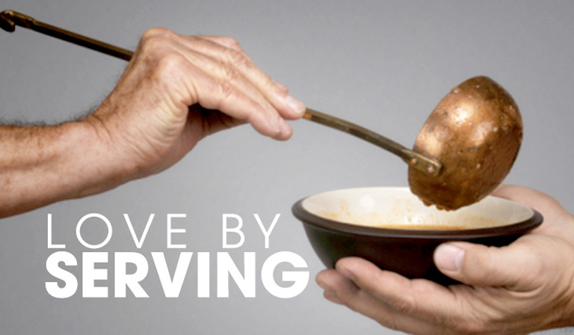
Gospel: Matthew 22:34-40
Jesus’ summation of morality as the twofold commandment of love
When the Pharisees heard that he had silenced the Sadducees, they gathered together, and one of them, a lawyer, asked him a question to test him. “Teacher, which commandment in the law is the greatest?”
He said to him, “‘You shall love the Lord your God with all your heart, and with all your soul, and with all your mind.’ This is the greatest and first commandment. And a second is like it: ‘You shall love your neighbour as yourself.’ On these two commandments hang all the law and the prophets.”
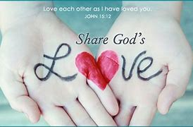
REFLECTIONS:
Life is becoming increasingly complex!
All our texts today suggest one clear and practical principle: loving God involves doing practical justice in our world. But even our superficially Christian society is full of people who show little respect for love or justice. Political and economic life is ruled by values far from those of the Gospel. Greed, and fierce desire for power and profit can be seen in our daily papers. We are closer to the paganism mentioned in St Paul’s letter than we may imagine. Today no less than then, the world is hostile to what the Lord Jesus represents, and it is hard for us to take a stand even on important issues of justice and compassion. Our Lord shows love of God and genuine love of the other as two basic aspects of the same call. There can never be a contradiction between the two, even though one may sometimes feel trapped in a situation where a particular law of Church or State seems to create a contradiction.
An approach to the second commandment about love could be by reflecting on how we love ourselves. Love of neighbour becomes virtually impossible in the age of self-hatred in which some fearful, discouraged people can find themselves. Loving the other as oneself only becomes possible if we have, or can grow into, a healthy, sane level of self-appreciation. This is a sound psychological principle, which should be mentioned in our churches even though Christian love transcends all the transient vogues of psychology. Its ideal is the example of Christ himself, with also his commitment to justice for the poor.
Recent years have seen a dramatic increase in the number of immigrants who have come to live our country Australia. We have moved from a mono-cultural to a multi-cultural, multi-racial society. Today’s readings invite us to reflect on how well we receive these strangers, make them feel at home in our society and in our church. “I was a stranger and you welcomed me.” They are distinct from us, and, often, different from us. The saying, “Birds of a feather flock together,” expresses the evident truth that like attracts like. It is tempting to frequent the company of people like ourselves. Yet, the Lord gathered about himself a community of great diversity. Even within the twelve there was to be found a tax-collector and a zealot, men from opposite ends of the political spectrum. In a similar way, the Spirit of the Lord at work in our lives prompts us to connect with those who are different from us, as well as those who are like us. The one we find initially strange can reveal the Lord to us in surprising ways.
For the Lord Jesus, what God wants from us above all else is love. There is no genuine love of God unless it finds expression in love of our neighbour, whoever they are. Love of neighbour, in turn, pre-supposes a healthy self-love, recognising and appreciating ourselves as fundamentally good, because we are created in the image and likeness of God..
In this spirit, we pray for a greater openness to the many ways the Lord comes to us in life. Amen.
